# Chapter 3 Homework - John Paukovits

1. What are the conventions for naming a class and naming a variable?
   1. Class names use camel casing (capitalizing the first letter of each word with no spacing) with a capital letter for the first work.
   2. Methods and variable names use camel casing but leave the first word lower case and capitalize the beginning of each word there after.
2. Assume a class has the following instance variable:

private String name;

Write the set and get methods to set and get the instance variable value.

1. 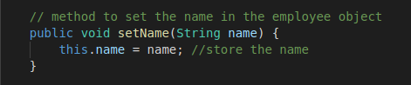
2. 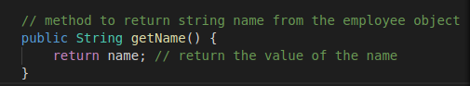
3. If the class Person has the instance variable String name, write the class’s constructor that will initialize the name instance variable using a parameter called name.

a. 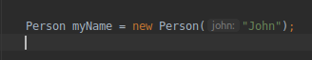

1. What is the purpose of the keyword new?
   1. The keyword new is a constructor that creates the object much like a built in method.
2. Write the Java code to instantiate an Account object from an Account class that has a default constructor?
   1. 